**Assignment 1: MS WORD REPORT**

1. **What are three conclusions we can make about Kickstarter Campaigns given the provided data?**
2. We can conclude that Kickstarter campaigns are mostly successful?



1. We can also conclude that Music and Theater were the most successful campaigns as seen below.

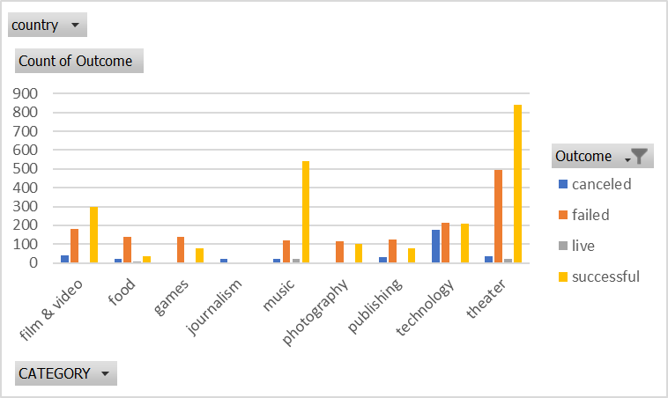

1. We can also conclude that the campaigns did not do well in the months towards the end of the year.

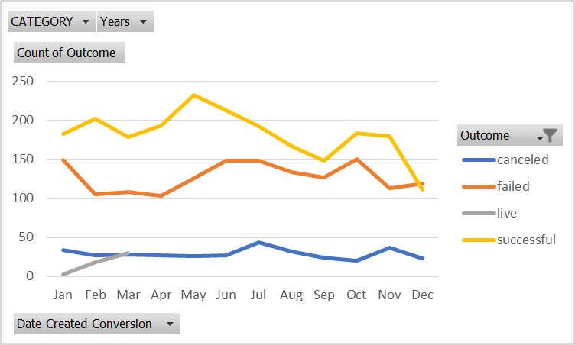

1. **What are some of the limitations of this dataset?**

One of the limitations is the change in date and time.

Some of the data is repeated like the category and sub-category.

**3. What are some other tables/graphs that we could create?**

-We could create a column or bar chart, pie chart.

-We could create a simple table or an excel table.